Data Analyst Technical Test - Forma AI

Ankur Kumar

SOLUTIONS for SQL queries -

Answer 1:

SELECT cust_id, seg_name, update_at

FROM segments

WHERE active_flag = 'Y'

ORDER BY update_at;

Output:

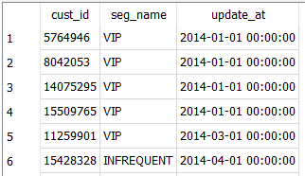

Answer 2:

SELECT t.prod_id, p.prod_name, count(DISTINCT t.trans_id) as count

FROM transactions t

JOIN products p

ON t.prod_id = p.prod_id

WHERE t.trans_dt BETWEEN '2015-12-31' AND '2016-06-01'

GROUP BY p.prod_id;

Output:

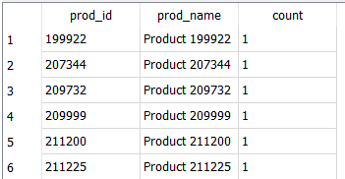

Answer 3:

SELECT cust_id , seg_name, max(update_at) as update_at

FROM segments

WHERE update_at <= '2016-03-01'

GROUP BY cust_id;

Output:

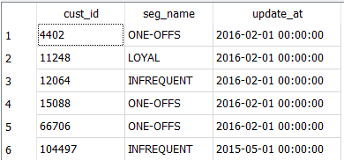

Answer 4:

Select seg_name, category, max(revenue) as revenue

FROM

(

SELECT s.seg_name, p.category, SUM(t.item_qty * t.item_price) revenue

FROM segments s

JOIN transactions t

ON s.cust_id = t.cust_id

JOIN products p

ON p.prod_id = t.prod_id

WHERE s.active_flag = 'Y'

GROUP BY s.seg_name, p.category

)

GROUP by seg_name;

Output:

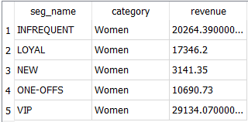

**Query to display the table before converting it to CSV/Sql**

select t.trans_id, t.trans_dt, t.cust_id, t.prod_id, t.item_qty, t.item_price,  
s.seg_name, s.update_at, s.active_flag, p.prod_name, p.brand, p.category  
from transactions t  
join segments s  
on t.cust_id =  s.cust_id  
join products p  
on t.prod_id = p.prod_id